**Cairo University Faculty of Computers and Information**



**Software Engineering II**

**Software design specification document**

**2020**

**Project Team**

|  |  |  |  |
| --- | --- | --- | --- |
| **ID** | **Name** | **Email** | **Mobile** |
| 20170253 | Mohamed Mohsen Abdel Sallam | midomohsen11@gmail.com |  |
| 20170232 | Mohamed Sameh Omar | Mohamedsameh99909@gmail.com |  |
| 20170224 | Muhammad Bakr Abdel Hafez | mbakr7757@gamil.com |  |

**TA. Mahmoud Hadad**

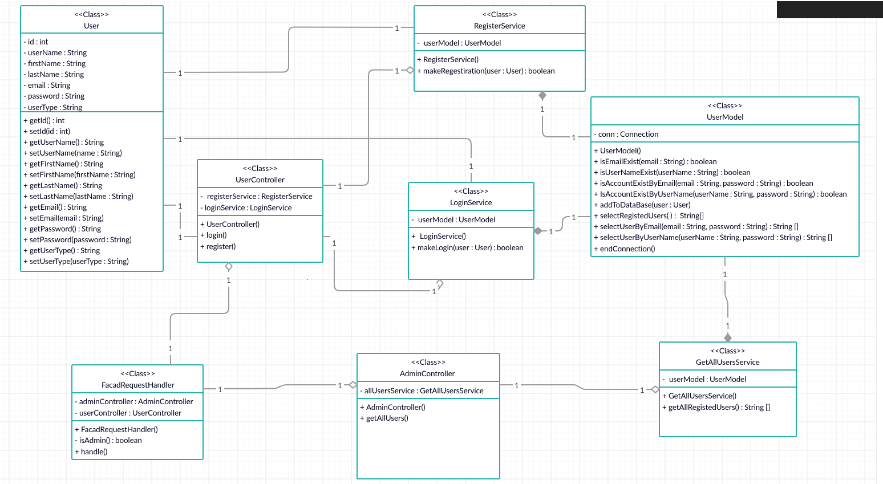**Class diagram design**

**Sequence diagram design**

* **Register**

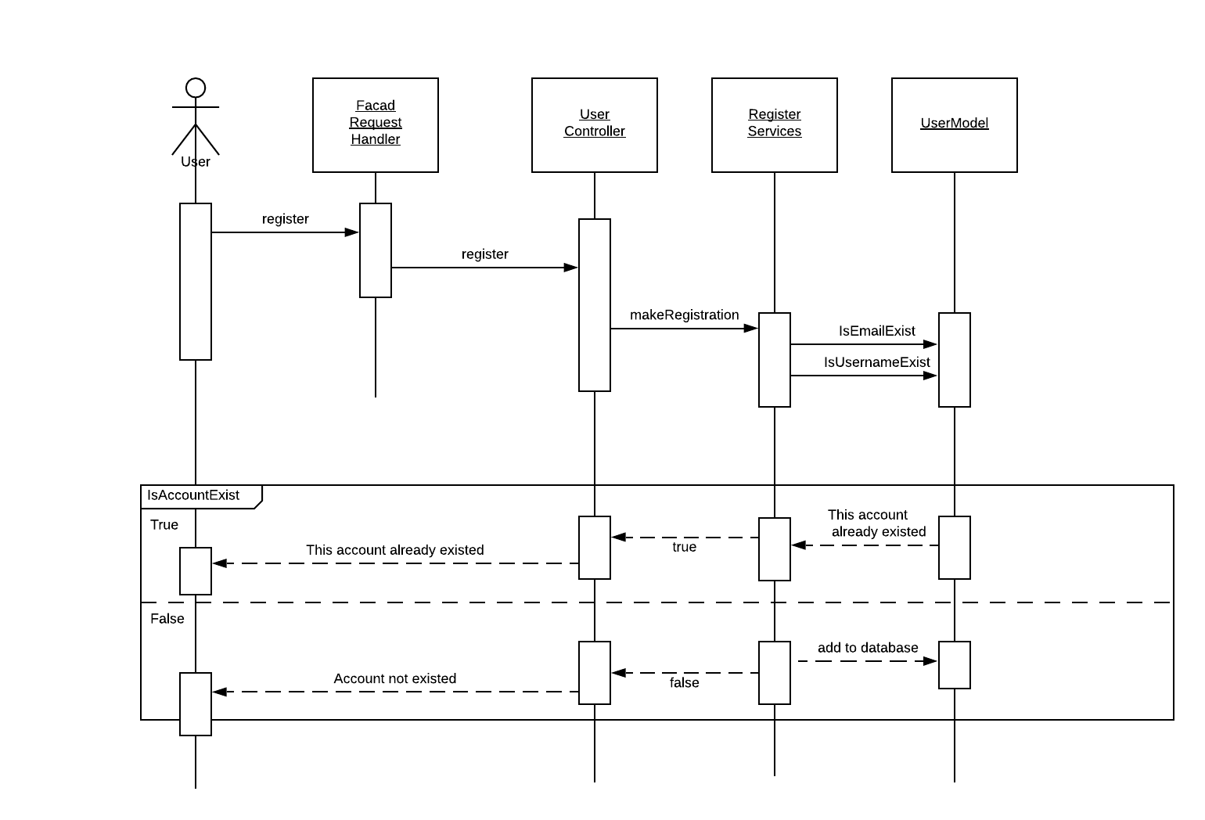

* **Login**

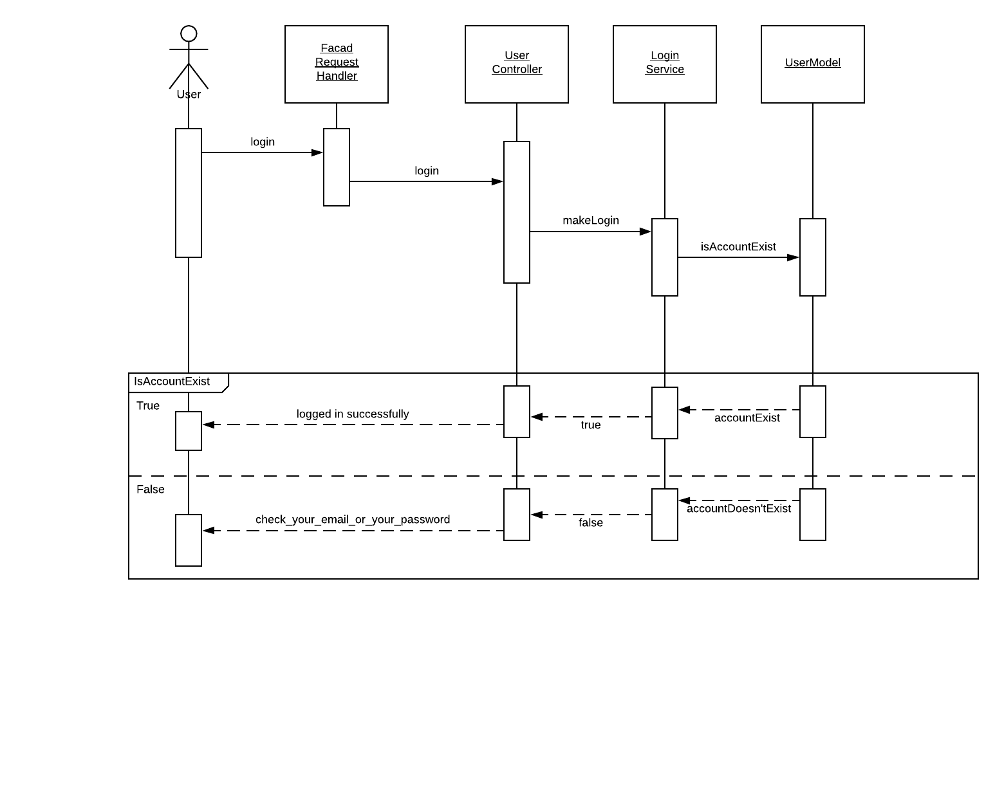

* **Get All Register Users**

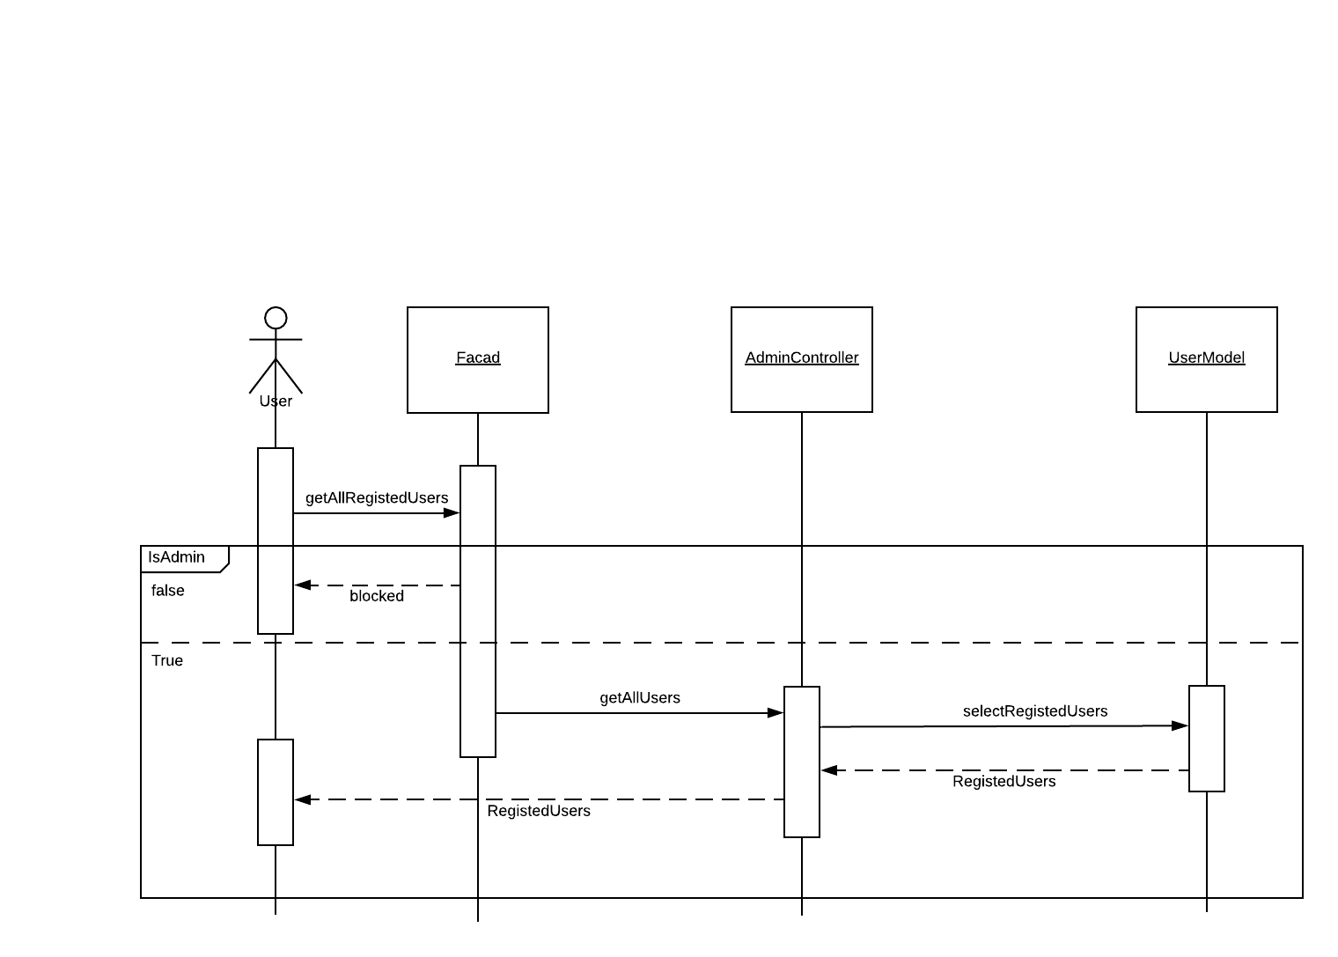

**Github repository link**

* **https://github.com/Mohamedmohsenn/Online-Store**